## How well does the audit trail on the git repository reflect the groups work?

Using a git repository has been a good experience for the group. The repository was heavily used, with over 150 commits added to the repository. Some members used the Git website to add their commits, some used the application and others used command line. Though there’s differences in the number of commits made, all members equally made great use of the repository to work collaboratively, particularly on the Gitpage.

Dylan and Josh took a lead in this assignment, something shown through the amount of commits they had. They both often made frequent commits to make minor changes fixing spelling errors, theme changes or assisting in constructing drafts.

Many of Dylan’s earlier commits were minor adjustments to the content and theme of the Gitpage, as his theme was used. Dylan’s later commits were further changes to the Gitpage, report drafts and various other documents, assisting the team where possible. Josh completed a similar number of commits through tweaking of reports such as spell checking, minor fixes and adding his own contribution. Arin, the last member to join the group, has added many commits. Arin made use of the Git website to make commits, resulting in a slightly confusing audit trail where files are first deleted then re-added anytime he uploads changes. Jacob, Ryan and Seth were all assigned individual reports to do. This is shown briefly in the audit trail, though most of this work was done locally with many changes submitted at once.

As a group it was agreed the audit trail alone doesn’t directly reflect the amount of work done by team members. An example of this is seen with the number of commits Seth has made; far less than others. Seth was assigned the Autonomous Vehicles Report and prepared the foundation for our Project Idea report. As these reports were mostly completed locally, the audit trail doesn’t reflect the amount of work done to produce these documents.

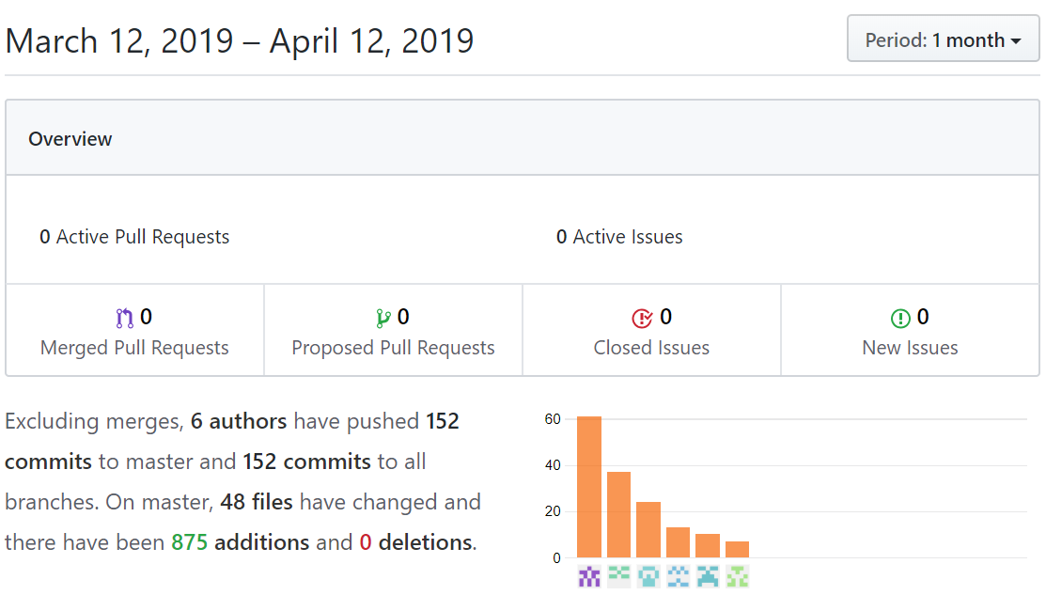In summary, though not a great indicator of the level of work done by each member, the Git audit trail does accurately reflect the live changes made to the Gitpage and repository files. This audit trail would prove beneficial in checking notes after code is changed. At the very least, one could establish who changed the code and contact them to request further information. In our case, most commits were made with clear, descriptive information explaining changes made.

Figure - Git Pulse overview

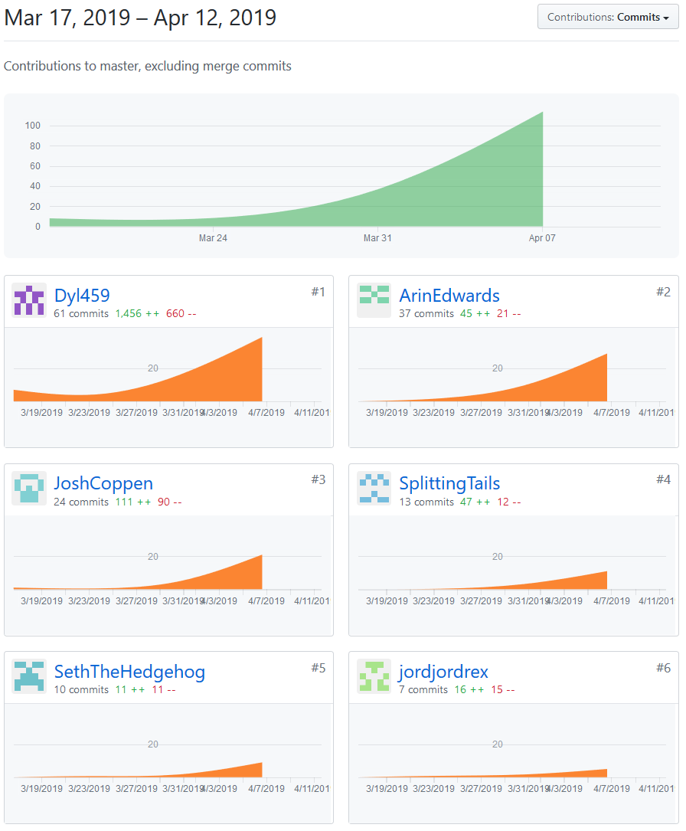TechPro’s Git page: <https://joshcoppen.github.io/Assignment-2-Team-Project/>

Figure - Git Repository Contributions Dashboard

Git contributions Dashboard

## TechPro’s Git Repository: <https://github.com/JoshCoppen/Assignment-2-Team-Project>